[COVID Data](https://usafacts.org/visualizations/coronavirus-covid-19-spread-map/state/texas)

[Extracted monthly cases csv files](https://drive.google.com/file/d/1vv0UprS3kQDAh0UenBDnkgwzTDEe1Axj/view?usp=sharing):

Model type: ANOVA --adoption, surrender, Impounds before and during Covid-19 pandemic

(Intake type: Stray,Owner Surrender, Foster comparison → outcome type: adoption (goal))

Independent variable: regular Time / covid-19 pandemic

Predict : Oct.2020 to Sep.2021 outcome adoption cases

Data exploration:

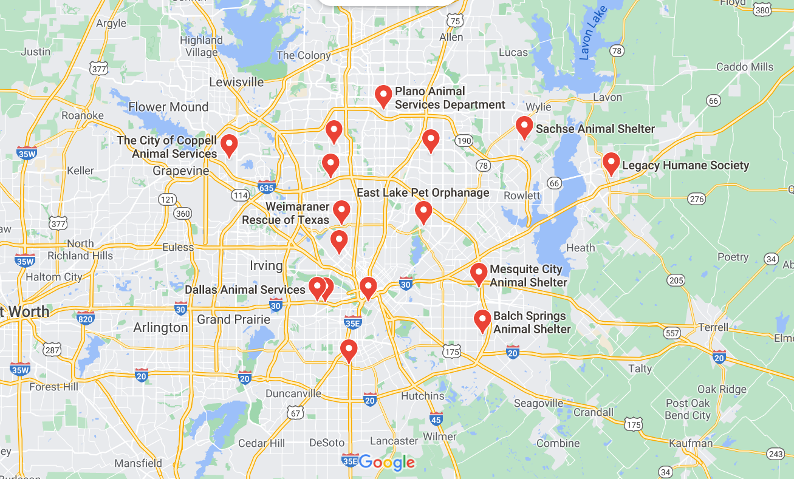

Figure 1: Shelter location in Great Dallas area animal shelter from [google map](https://www.google.com/maps/search/animal+shelter+near+Dallas,+TX/@39.722037,-162.8105927,3z/data=!3m1!4b1)

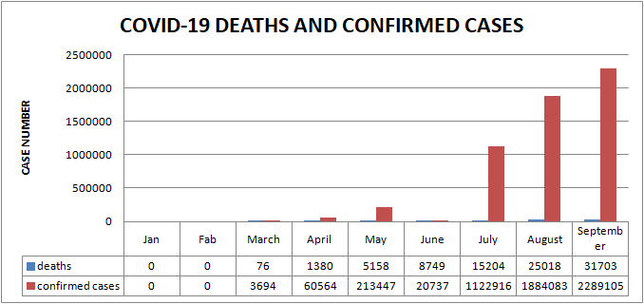

Figure 2: Jan 2020 to Sep 2020 covid-19 pandemic Dallas county deaths and confirmed cases

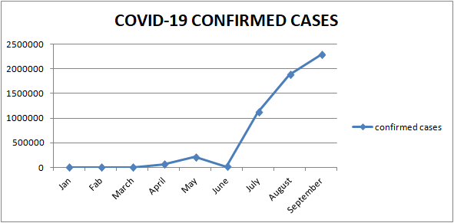

Figure 3: Jan. 2020 to Sep. 2020 covid-19 pandemic Dallas county confirmed cases

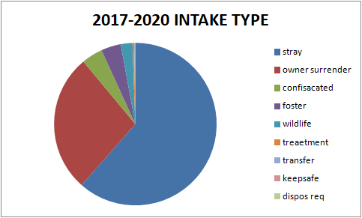

Figure 4: Intake type proportion

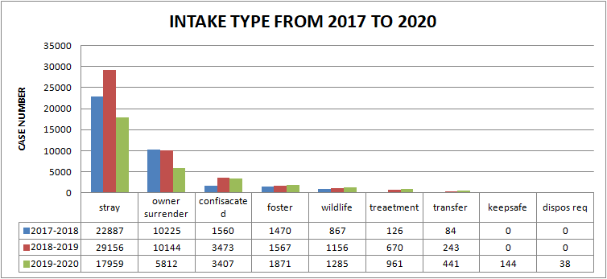

Figure 5: Intake type in animal shelter from 2017 to 2020

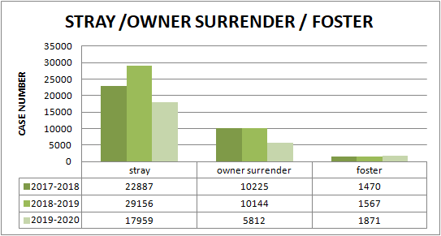

Figure6: Stray, Owner Surrender, Foster From 2017 to 2020

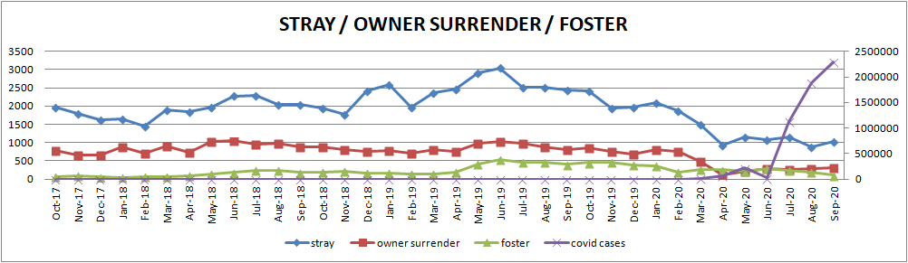

Figure6.2: Stray,Owner Surrender, Foster from Oct. 2017 to Sep. 2020

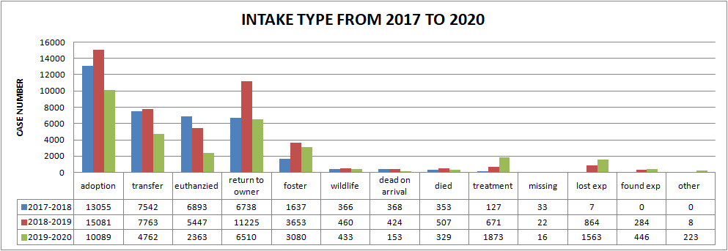

Figure 7: Intake type from 2017 to 2020

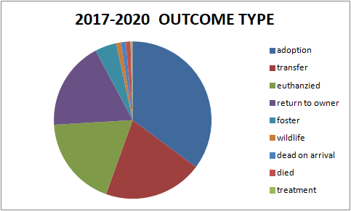

Figure 8: Outcome Type from 2017 to 2020

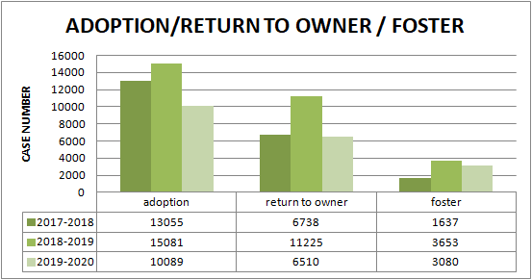

Figure 9: Outcome type: adoption, return to owner, and foster numbers

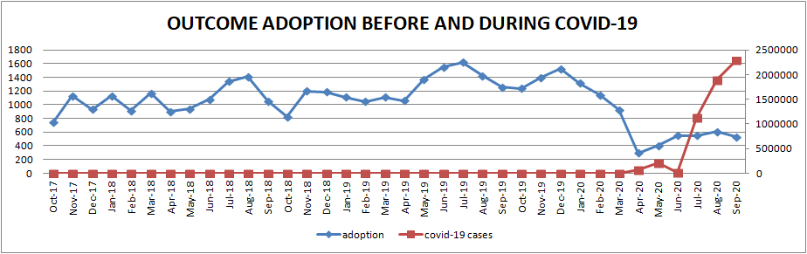

Figure 10: Outcome type adoption before and during covid-19 pandemic

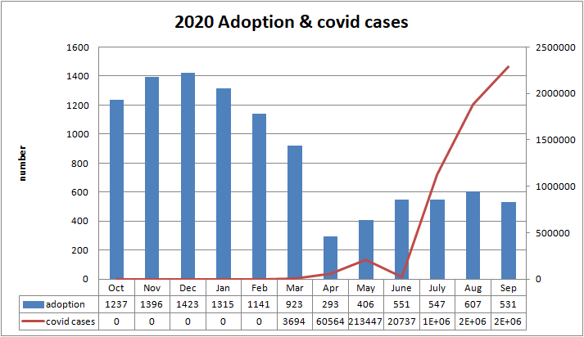

Figure 11: 2020 adoption numbers and covid-19 confirmed cases

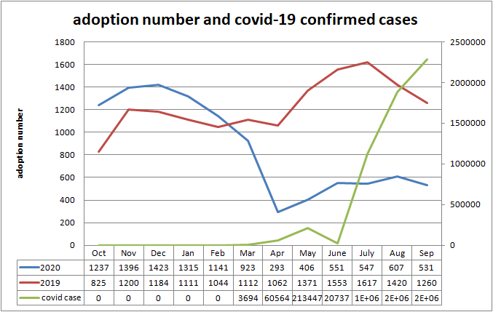

Figure 12: 2019,2020 adoption numbers comparison

**GOAL: determine what the impacts of COVID-19 cases are on Dallas animal services.**

Note: We are acting as business consultants to Dallas animal services and will summarize our findings to them with recommendations on how to proceed.

Question: Does Covid-19 affect Dallas animal services activities?

Ha=There is a difference between pre covid19 and post covid19

DATASET: covid 19 cases, oct 2017- October 2020 Dallas animal services activities

1. We first look at overall graphs from our sample data.



Figure6.2: Intake type: Stray,Owner Surrender, Foster from Oct. 2017 to Sep. 2020



Figure 10: Outcome type adoption before and during covid-19 pandemic

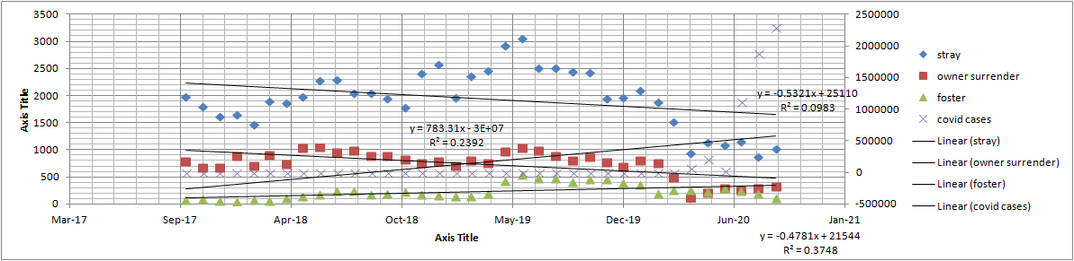

PART 1: Do the data sample averages for each year differ from one another?

Independent sampleT-TEST: the means of two different groups

Is there a difference between 2017-2018 & 2018-2019 / 2018-2019 & 2019-2020 ?

Null H: no difference

Ha: different

|  |  |  |
| --- | --- | --- |
| T-TEST | 2017-2018 &2018-2019 | 2018-2019 &2019-2020 |
| STRAY | 0.000794(CHANGE) | 0.0000764(CHANGE) |
| OWNER SURRENDER | 0.892(NO CHANGE) | 0.000286838(CHANGE) |
| FOSTER | 0.002227(CHANGE) | 0.919741(NO CHANGE,BUT IF YOU SEE THE GRAPH, YOU WILL KNOW HOW THE NUMBERS COME FROM) |

**Details on PART 1:**

Data sample 1: FY18 (oct 2017-sept 2018) between FY19 (oct 2018-sept 2019) surrenders, adoptions, strays

STARY GROUP T-TEST: 0.000794

|  |  |  |
| --- | --- | --- |
| MONTH | 2017-2018 | 2018-2019 |
| OCT | 1978 | 1953 |
| NOV | 1805 | 1776 |
| DEC | 1617 | 2410 |
| JAN | 1650 | 2580 |
| FEB | 1460 | 1967 |
| MAR | 1890 | 2368 |
| APR | 1857 | 2462 |
| MAY | 1974 | 2915 |
| JUN | 2279 | 3047 |
| JULY | 2290 | 2515 |
| AUG | 2050 | 2515 |
| SEP | 2047 | 2441 |

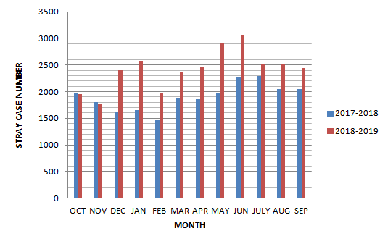

OWNER SURRENDER GROUP T-TEST: 0.892

|  |
| --- |
|  |

|  |  |  |
| --- | --- | --- |
| Month | 2017-2018 | 2018-2019 |
| OCT | 786 | 879 |
| NOV | 665 | 812 |
| DEC | 667 | 750 |
| JAN | 886 | 778 |
| FEB | 706 | 710 |
| MAR | 903 | 796 |
| APR | 742 | 759 |
| MAY | 1028 | 969 |
| JUN | 1041 | 1032 |
| JUL | 950 | 976 |
| AUG | 975 | 892 |
| SEP | 888 | 803 |

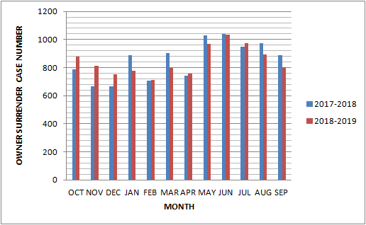

FOSTER CASE T-TEST:0.002227

|  |  |  |
| --- | --- | --- |
| MONTH | 2017-2018 | 2018-2019 |
| OCT | 69 | 192 |
| NOV | 96 | 223 |
| DEC | 58 | 166 |
| JAN | 47 | 162 |
| FEB | 72 | 134 |
| MAR | 64 | 138 |
| APR | 99 | 189 |
| MAY | 136 | 419 |
| JUN | 179 | 529 |
| JUL | 245 | 469 |
| AUG | 240 | 467 |
| SEP | 177 | 397 |

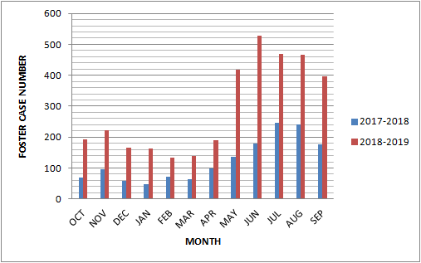

Data sample 2:T-TEST: FY20 (oct 2019-sept 2020) between FY19 (oct 2018-sept 2019) surrenders, adoptions, strays

STRAY CASE T-TEST:

|  |
| --- |
| 0.0000764 |

|  |  |  |
| --- | --- | --- |
| MONTH | 2018-2019 | 2019-2020 |
| OCT | 1953 | 2426 |
| NOV | 1776 | 1947 |
| DEC | 2410 | 1966 |
| JAN | 2580 | 2091 |
| FEB | 1967 | 1879 |
| MAR | 2368 | 1510 |
| APR | 2462 | 934 |
| MAY | 2915 | 1142 |
| JUN | 3047 | 1078 |
| JUL | 2515 | 1150 |
| AUG | 2515 | 871 |
| SEP | 2441 | 1022 |

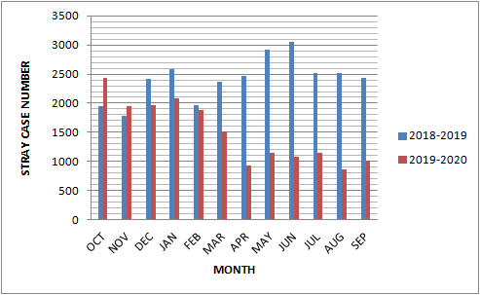

OWNER SURRENDER T-TEST:

|  |
| --- |
| 0.000286838 |

|  |  |  |
| --- | --- | --- |
| MONTH | 2018-2019 | 2019-2020 |
| OCT | 879 | 865 |
| NOV | 812 | 760 |
| DEC | 750 | 693 |
| JAN | 778 | 809 |
| FEB | 710 | 749 |
| MAR | 796 | 483 |
| APR | 759 | 114 |
| MAY | 969 | 210 |
| JUN | 1032 | 287 |
| JUL | 976 | 250 |
| AUG | 892 | 285 |
| SEP | 803 | 319 |

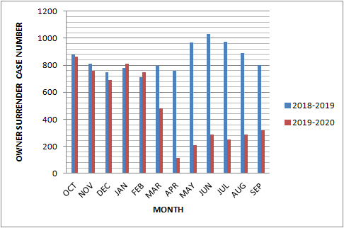

FOSTER T-TEST:

|  |
| --- |
| 0.919741 |

|  |  |  |
| --- | --- | --- |
| MONTH | 2018-2019 | 2019-2020 |
| OCT | 192 | 452 |
| NOV | 223 | 460 |
| DEC | 166 | 391 |
| JAN | 162 | 361 |
| FEB | 134 | 198 |
| MAR | 138 | 264 |
| APR | 189 | 251 |
| MAY | 419 | 221 |
| JUN | 529 | 290 |
| JUL | 469 | 232 |
| AUG | 467 | 194 |
| SEP | 397 | 105 |

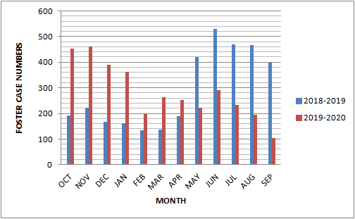

**Data sample 3: FY20 T-TEST: PRE-COVID(OCT 2019-FEB 2020) between FY20 POST-COVID(MAR 2020-SEP 2020)**

Test: Anova

FY 2017-2018: surrenders, adoptions, strays

|  |  |  |  |  |
| --- | --- | --- | --- | --- |
|  | Month | stray | owner surrender | foster |
|  | Oct-17 | 1978 | 786 | 69 |
|  | Nov-17 | 1805 | 665 | 96 |
|  | Dec-17 | 1617 | 667 | 58 |
|  | Jan-18 | 1650 | 886 | 47 |
|  | Feb-18 | 1460 | 706 | 72 |
|  | Mar-18 | 1890 | 903 | 64 |
|  | Apr-18 | 1857 | 742 | 99 |
|  | May-18 | 1974 | 1028 | 136 |
|  | Jun-18 | 2279 | 1041 | 179 |
|  | Jul-18 | 2290 | 950 | 245 |
|  | Aug-18 | 2050 | 975 | 240 |
|  | Sep-18 | 2047 | 888 | 177 |
| SUM |  | 22897 | 10237 | 1482 |
| MEAN |  | 1908.083 | 853.0833333 | 123.5 |

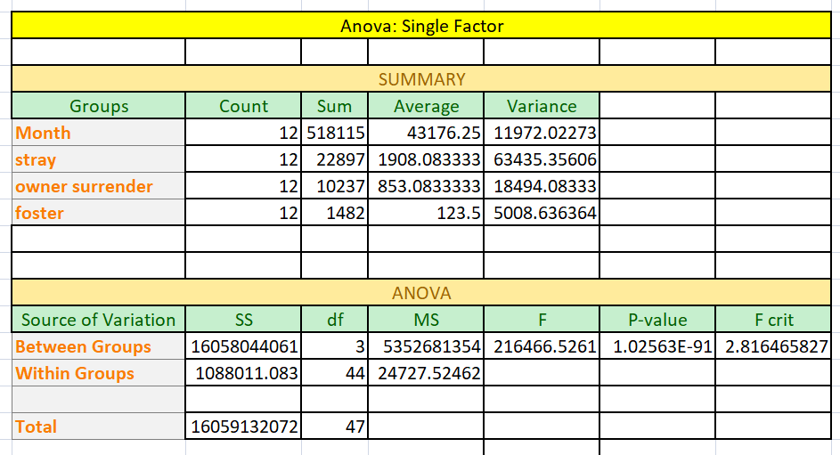

Pearson Correlation Coefficient to find coefficient

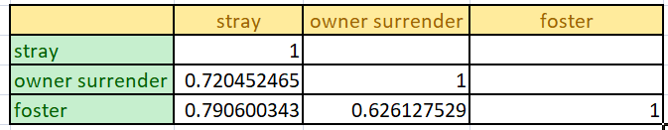

FY 2018-2019: surrenders, adoptions, strays

|  |  |  |  |  |
| --- | --- | --- | --- | --- |
|  | Month | stray | owner surrender | foster |
|  | Oct-18 | 1953 | 879 | 192 |
|  | Nov-18 | 1776 | 812 | 223 |
|  | Dec-18 | 2410 | 750 | 166 |
|  | Jan-19 | 2580 | 778 | 162 |
|  | Feb-19 | 1967 | 710 | 134 |
|  | Mar-19 | 2368 | 796 | 138 |
|  | Apr-19 | 2462 | 759 | 189 |
|  | May-19 | 2915 | 969 | 419 |
|  | Jun-19 | 3047 | 1032 | 529 |
|  | Jul-19 | 2515 | 976 | 469 |
|  | Aug-19 | 2515 | 892 | 467 |
|  | Sep-19 | 2441 | 803 | 397 |
| SUM |  | 28949 | 10156 | 3485 |
| MEAN |  | 2412.417 | 846.3333333 | 290.4167 |

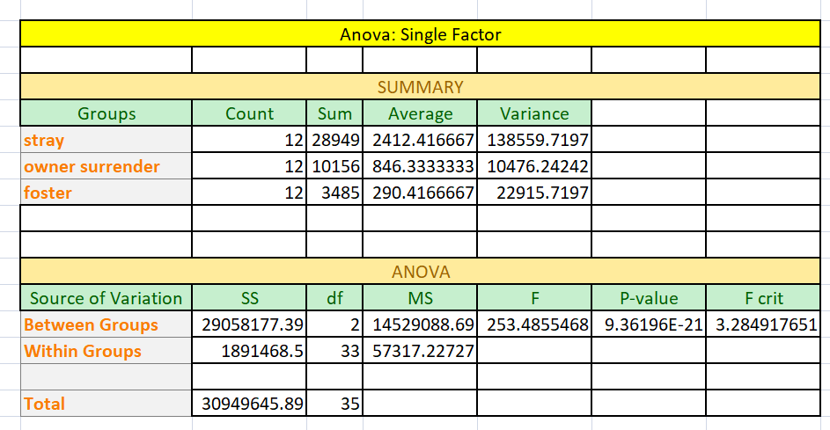

Pearson Correlation Coefficient to find coefficient

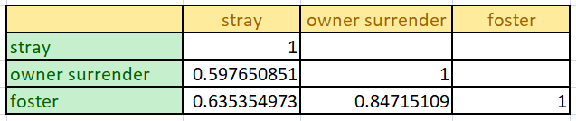

FY 2019-2020: surrenders, adoptions, strays

|  |  |  |  |  |
| --- | --- | --- | --- | --- |
|  | MONTH | STRAY | OWNER SURRENDER | FOSTER |
|  | Oct-19 | 2426 | 865 | 452 |
|  | Nov-19 | 1947 | 760 | 460 |
|  | Dec-19 | 1966 | 693 | 391 |
|  | Jan-20 | 2091 | 809 | 361 |
|  | Feb-20 | 1879 | 749 | 198 |
|  | Mar-20 | 1510 | 483 | 264 |
|  | Apr-20 | 934 | 114 | 251 |
|  | May-20 | 1142 | 210 | 221 |
|  | June-20 | 1078 | 287 | 290 |
|  | Jul-20 | 1150 | 250 | 232 |
|  | Aug-20 | 871 | 285 | 194 |
|  | Sep-20 | 1022 | 319 | 105 |
| SUM |  | 18016 | 5824 | 3419 |
| MEAN |  | 1501.333 | 485.3333 | 284.9167 |

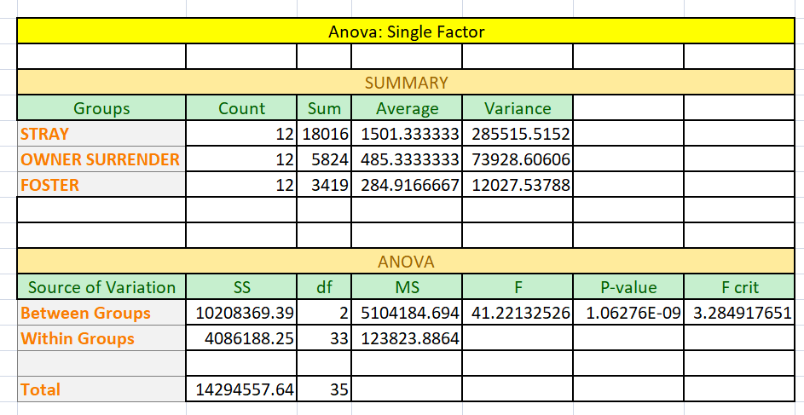

Pearson Correlation Coefficient to find coefficient

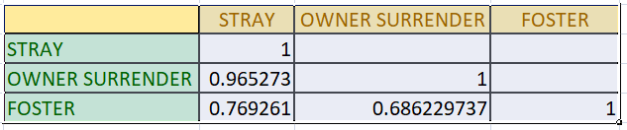

PART 2: Pearson Correlation Coefficient to find coefficient

Is there a correlation between covid 19 positive cases and adoptions?

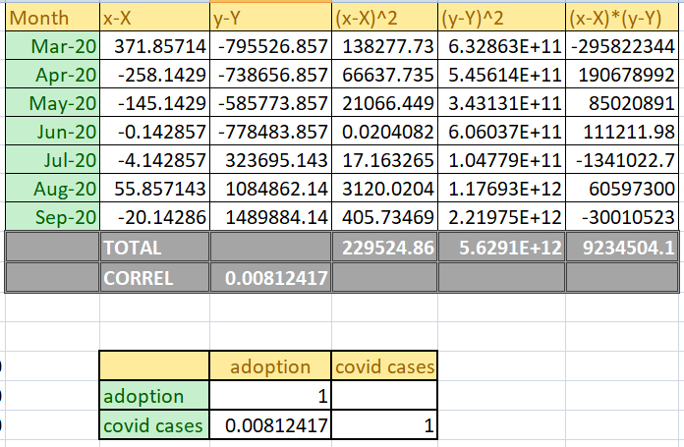

Is there a correlation between covid 19 positive cases and surrenders?

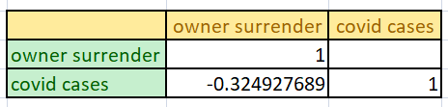

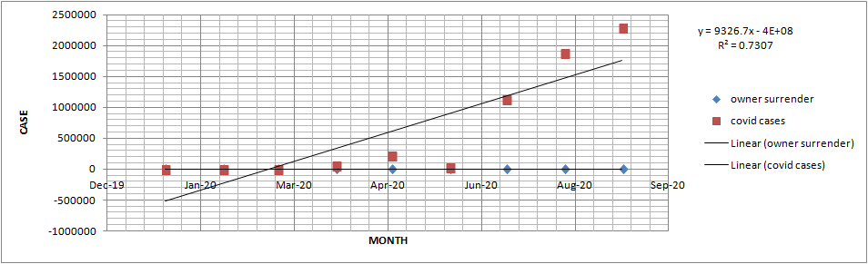

Is there a correlation between covid 19 positive cases and strays?

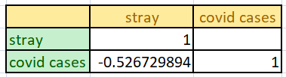

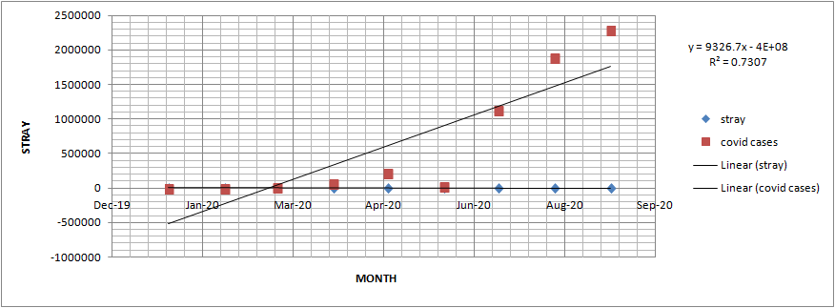

|  |  |  |  |
| --- | --- | --- | --- |
| Month | stray | owner surrender | covid cases |
| Jan-20 | 2091 | 809 | 0 |
| Feb-20 | 1879 | 749 | 0 |
| Mar-20 | 1510 | 483 | 3694 |
| Apr-20 | 934 | 114 | 60564 |
| May-20 | 1142 | 210 | 213447 |
| June-20 | 1078 | 287 | 20737 |
| Jul-20 | 1150 | 250 | 1122916 |
| Aug-20 | 871 | 285 | 1884083 |
| Sep-20 | 1022 | 319 | 2289105 |

Part 3: Conclusion

-Answer the questions from part 1 and part 2.

-Recommend how Dallas Animal Services should proceed.